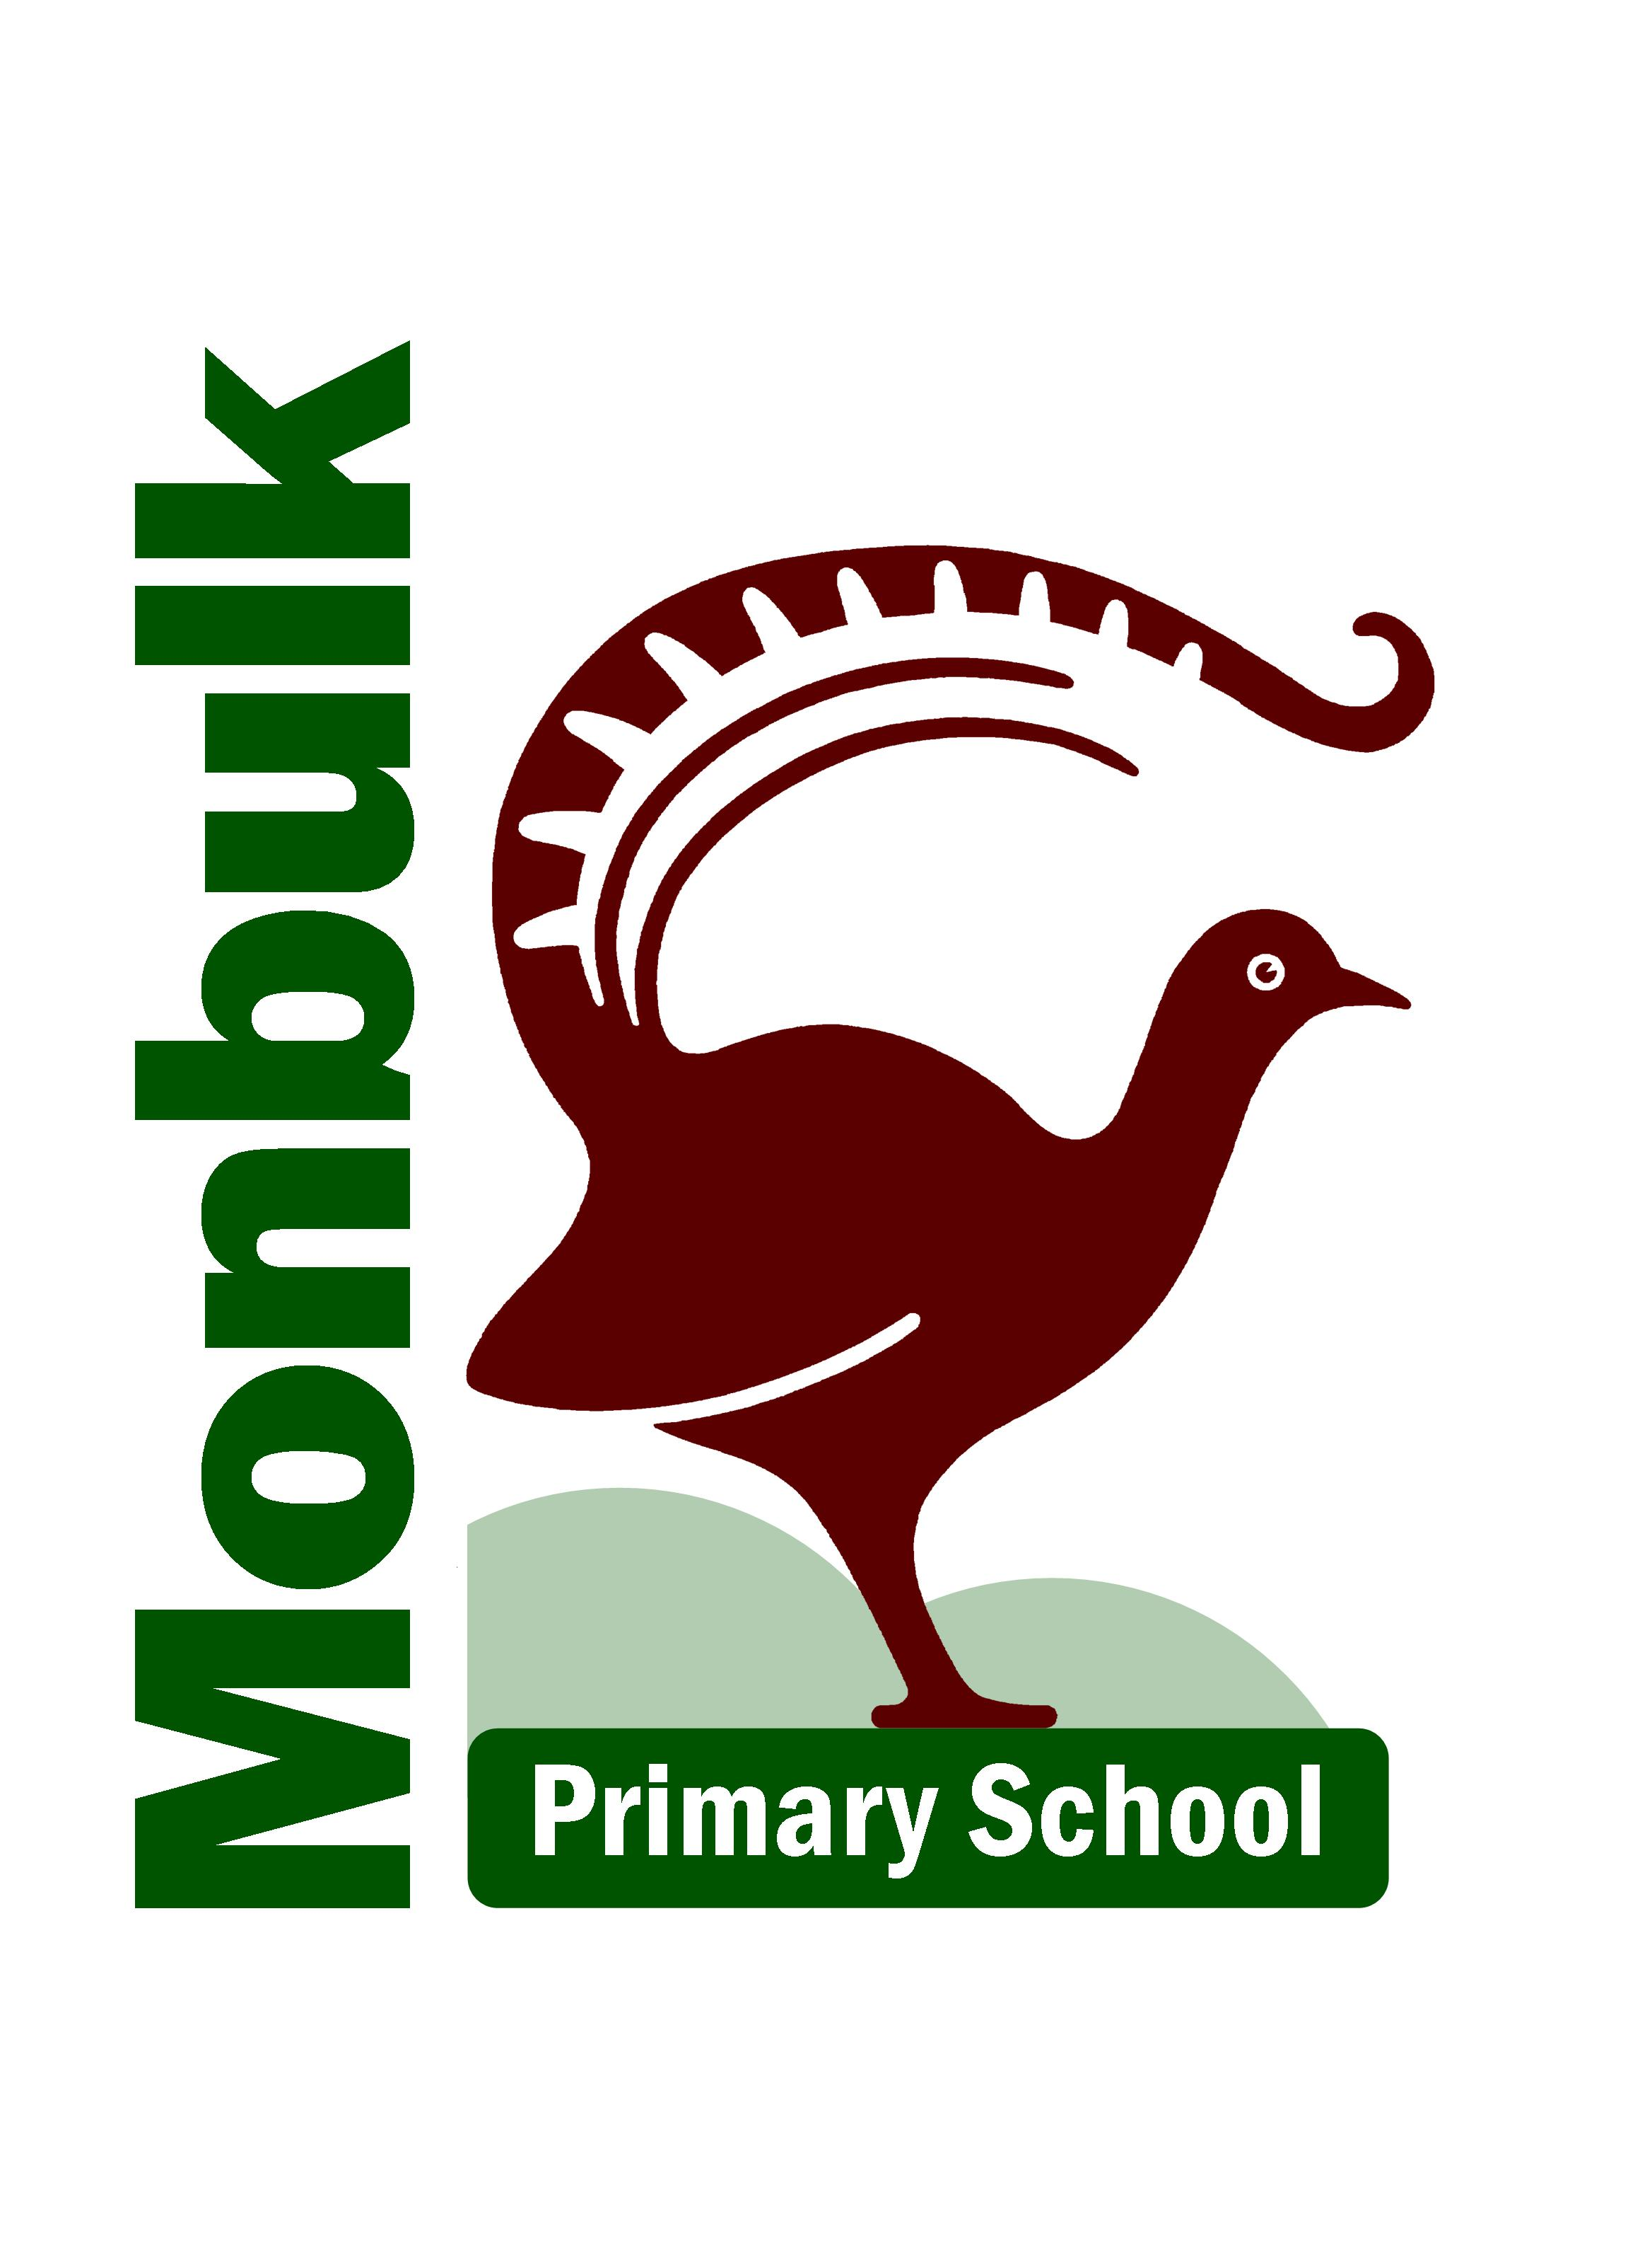

PREP PARENT HANDBOOK 2022
Monbulk Primary School
P.O. Box 231
Monbulk 3793
Telephone: 9756 6481
Mobile: 0498 387 851
Email: monbulk.ps@education.vic.gov.au
Website: www.monbulkps.vic.edu.au

WELCOME TO MONBULK PRIMARY SCHOOL
PREPS 2022
Principal Asst Principal Prep PLC Junior PLC 1&2
Estelle Alder Penelope Harris Amy Sawyer Grace Read
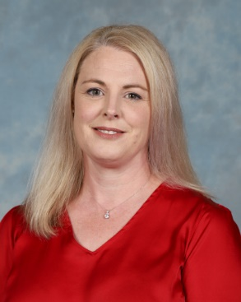
Middle PLC 3&4 Senior PLC 5&6 Business Manager Office Admin
Danielle Lamport Eden Byron-Thomsen Nicole Baird Cathy Piesley

CONTENTS
- School Vision
- Values
- School Motto
• Monbulk Primary School Mission Statement
• Guiding Principles
• Curriculum
• Ensuring a Smooth Transition
• School Hours
• What your child will need to bring to school
• Those first few days
• Reporting School Progress
• General Information
• School Calendar for 2022
- Before and After School Care

SCHOOL VISION
At Monbulk Primary School we endeavour to nurture and educate individual students within a safe and positive learning environment. Students will be active and responsible participants in their own learning, through a broad range of experiences.
At Monbulk we strive to build an involved community, one that fosters the achievement of personal best and helps make a difference to others.

VALUES
Respect, Relationships, Resilience and Responsibility.

SCHOOL MOTTO
Expect More, Achieve More.

MONBULK PRIMARY SCHOOL MISSION STATEMENT
Schools are about Learning and Development of Attitudes to Learning.

Teachers, parents and the wider community work together to:
• Present a wide range of key knowledge, beliefs and values to students.
• Provide a curriculum range which is balanced, comprehensive and coherent.
• Ensure regular evaluations of curriculum, policies and programs to safeguard student learning and success.
• Provide a caring and stimulating environment in which students become lifelong seekers of learning.

GUIDING PRINCIPLES
At Monbulk Primary School, the whole school works in a climate of trust and direction to assist the students to:
• Commit themselves to the pursuit of excellence.
• Develop their artistic skills.
• Value personal relationships
• Develop individual physical fitness, health and wellbeing.
• Appreciate that rights, responsibilities and respect are part of their school culture.
Our school is modelled on democratic principles and equity having one body only, the School Council to oversee and assist in the running of the school.

CURRICULUM
The curriculum offered to students is within the Victorian Curriculum and includes such things as:

• English
• Mathematics
• Science
• Health and Physical Education
- Art
• Music.
- S.T.E.M. program (Science, Technology, Engineering and Mathematics)
• Inquiry - History & Geography
- Respectful Relationships – Personal and Social Capabilities
- Languages
- Stephanie Alexander Kitchen and Garden Program – Cooking Grades 3 to 6 (construction of the new kitchen will be complete by the end of 2021)

ENSURING A SMOOTH TRANSITION
Assessment Week
From February 1st to February 4 2022, Prep students will be booked in for an assessment session with their teacher. This will last about 1 hour. Interview times will be advised in January.

SCHOOL HOURS
On the first day of school for Preps, Monday 7th Feb, school commences at 9.00am and the children will be dismissed at 1:00pm

Bell Times
- Bell rings at 8.55am for children to enter their classroom.
• School begins at 9.00am.
• Morning Recess is 10.40 – 11.10am.
• Supervised lunch in classroom from 12.50 to 1.00pm.
• Lunch play, children are outside from 1.00 to 1.50pm.
• Dismissal time is 3.30pm each day starting Monday 14th February 2021 for Preps

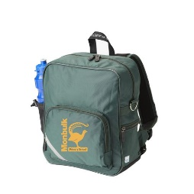
WHAT YOUR CHILD WILL NEED TO BRING TO SCHOOL

School Bag
Please ensure the bag you purchase is a decent size. The bag sold through Spartan is a good size and hard wearing and supports their back.

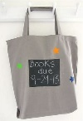
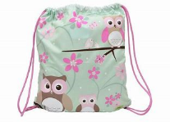
Library Bag
The preferred item is a cloth bag, approximately 30 x 40cm with a drawstring or carry bag with handles. This will be used to carry borrowed library books.

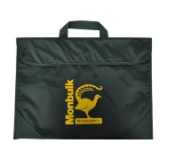
Big Green Satchel
To keep notices neat and safe, also to keep classroom readers separate from borrowed library books. Great for sending notes between teacher and parents. The PVC satchel is available from Spartan.
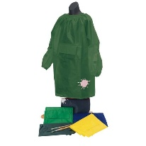
Art Smock
Spartan has for sale ready-made Art Smocks for the junior grades. The senior grades are encouraged to bring an old business shirt or something similar to protect their school uniform.

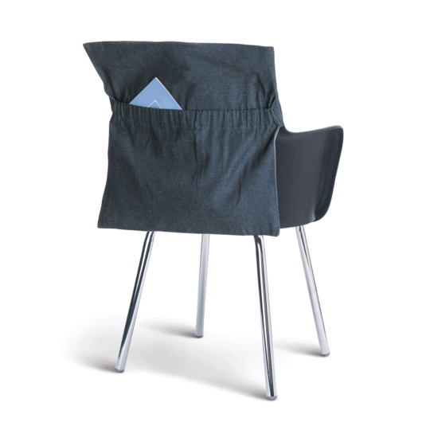
Chair Bag
For storage of your child’s work. The preferred material for your child’s chair bag is denim/heavy cord. When decorating the chair bag with fun designs please include your child’s name for easy identification in the classroom. Chair bags are used from Prep to grade 2. Denim chair bags are available from Spartan.

Yellow Prep Hat
Your child will receive a special yellow prep hat in the last session of transition in December to wear at school whilst completing Prep.

All these items are essential and will be needed from the first day of school.

THOSE FIRST FEW DAYS
It is important to discuss the coming event with your child, to ensure that they feel happy and relaxed about starting school.

A social story, ‘Beginning School’ will be posted to you in January for you to read together with your child. The purpose of this will be to help your child get ready for school.

We will communicate with you before the first day to advise of drop off arrangements and a possible meet and greet depending on restrictions.

Helping your child to master certain skills before schools starts, will assist in an easy adjustment. Please refer to the social story ‘Beginning School’ for suggestions.

All your child’s personal belongings MUST be named with a waterproof marker, i.e. Clothes, lunch box and lid and drink bottle.

REPORTING SCHOOL PROGRESS
A discussion between parents and teachers is the most effective method for reporting progress. It is important that parents and teachers make sure every effort
is made to keep communication open on all matters relating to the development of the child.

During the year, parent-teacher discussions will be arranged to allow for exchange of information between school and home. The home book is also an excellent means for getting messages to your child’s teacher and vice versa.

However, if at any time you wish to discuss your child’s work or provide information that may be affecting progress, please email your child’s teacher for an appointment, so that a mutually convenient time can be arranged.

GENERAL INFORMATION
Uniform
Uniform is available for purchase online at www.spartanschoolworld.com.au or from Spartan School World Retail Shop located at 1/210-214 Canterbury Rd, Bayswater North. Online orders may be delivered direct to your home for a small fee or a weekly delivery to the school free of charge.
Green Bomber Jacket or Hoodie, polo, checked tunic and hat can be purchased at Spartan. Other items available from general department stores consist of:-
Green and white checked gingham dress, white skivvy for under tunic, Black pants/shorts/leggings or skirts, Black or White socks and black shoes.
Please note: Open toed shoes including Thongs and Crocs are not considered safe or suitable footwear to wear to school.

Absences
Do not take your child away from the school ground, other than at home time, without notifying the class teacher and signing the child out at the office. If your child is absent from school for any reason, please update the absent note on compass or phone the office on the morning of absence (there is now a designated phone line for this purpose). You can also fill out an Absence Note and send it to school on their return. If you are taking your child on a family holiday, outside school holiday times, please process on Compass or drop a note to the office before you take off.
Book Club
Book Club catalogues are sent home throughout the year. This is a good opportunity to purchase quality books at reasonable prices. Orders can be made online (see catalogue for details) otherwise cash payments need to be returned to the school by the due date, in an envelope marked clearly with your child’s name and room number. Books generally take about three weeks to be processed and delivered. Cheques should be made out to Scholastic Books not Monbulk Primary School. Scholastic Book orders are processed by a parent who volunteers their time.

Sunsmart
The School’s Sunsmart Policy requires all children to wear a wide-brimmed hat during outdoor activities, i.e. P.E. and also recess and lunch times, during Terms1 and 4.

Illness
If your child is ill, please keep them at home. We have a sick-bay for students suddenly taken ill – please note the emphasis on suddenly. If your child is not fit to attend school, it is not advisable to send them. A sick child cannot learn or function effectively and it is not fair on the rest of the grade and the teacher.

Medicines
If your child is taking or has prescribed medication, we request that you either arrange to dispense the medicines at school yourself, or collect the required form from the office, whereby the medication will be dispensed by the ladies in the office, as per doctor’s instructions. Medication should not be stored in school bags during the day. Asthma inhalers are the exception to this rule.

Monny Mag
As a means of keeping you in touch with what is happening within the school, our newsletter is published fortnightly and available to view on Thursday afternoons via Compass under the school document tab or via our website under the news tab. www.monbulkps@education.vic.gov.au . Most communications from school are via Compass by email or text notifications.

Parent Payment Contribution
The parent payment contribution for 2021 is $275.00 for Prep to grade 2 and for children in Grades 3 to 6 is $305.00 – this includes access to Netbooks, S.T.E.M. and the Stephanie Alexander Kitchen Garden Programs. The 2022 amount is subject to change on the approval at School Council later in the year. There is also a suggested Voluntary Charge of $50 towards our Building Fund (which is fully tax deductible). 2022 fee schedule will be forwarded to you in November 2021 with more details.

Punctuality
Help your child to be punctual. School begins at 9.00am and it is an unsettling experience for young children to have to walk into class/assembly late. It is also not fair on the teacher and rest of the students in the grade, as important instructions are given to students at the beginning of each day and the teacher will be forced to repeat these to students who arrive late, and this takes up valuable classroom time. If you arrive at school any time after 9.00am you are required to sign your child in at the office.
If your child arrives home during school hours, please notify the school immediately.
Safety
Encourage your child to follow the basic rules, such as:
• A designated meeting place, if you are picking your child up.
• Look both ways before crossing the road.
• Refuse rides with strangers.
• If you walk your child to school, educate your son/daughter in the use of school crossings.

SCHOOL CALENDAR FOR 2022
Term 1: 28/01/2022—08/04/2022 – (Last day dismissal – 2.30pm)
Term 2: 26/04/2022—24/06/2022 – (Last day dismissal – 2.30pm)
Term 3: 11/07/2022—16/09/2022 – (Last day dismissal – 2.30pm)
Term 4: 03/10/2022—20/12/2022 – (Last day dismissal – 1.30pm)
Our school newsletter ‘Monny Mag’ comes out fortnightly and will keep you informed of Public Holidays and Curriculum Days in the school year. The following dates have already been ear marked.
- Curriculum Days 28 January
• Labour Day Monday 14 March
- Anzac Day Sunday 25 April
• The Queen’s Birthday Public Holiday - Monday 13 June
- AFL Grand Final Eve Public Holiday - TBA
• Melbourne Cup Day Public Holiday - Tuesday 1 November
- Preps First Day at School Monday 7th February 2022

School Assemblies
Whole school assemblies are held each Friday at 3pm. Parents are welcome to attend all assemblies, subject to health advice from DHHS regarding Covid 19 restrictions.

BEFORE AND AFTER SCHOOL CARE
A ‘Before and After School Care Program’ is run each day by OSHClub, which is located in our beautiful Arts Building.
Enrolment procedures and any other details are set out on the enclosed brochure provided by OSHClub.
Ms Aleesha Gist is the co-ordinator for OSHClub phone 0438 568 149.

